 [**How to edit a user's personal information**](https://sharepoint.rackspace.com/Learning/Articles/Pages/Editing-Users-Personal-Information.aspx)

As the SharePoint Administrator of your SharePoint 2013 site, it is important to edit your users' information.  You have the ability to change everything from their first name to adding a photo to their profile. In another case, what if the users email has changed; you can also change this as the Administrator.

To follow along with this example, you will need to log in to your Tenant Admin site. Simply append /admin to the URL of your site (for example: https://company.atrackspace.com/admin). You cannot complete the following steps from the Root site.  Further, not all users have access to the Tenant Admin site; please talk to the Site Administrator for your tenant to gain access.)

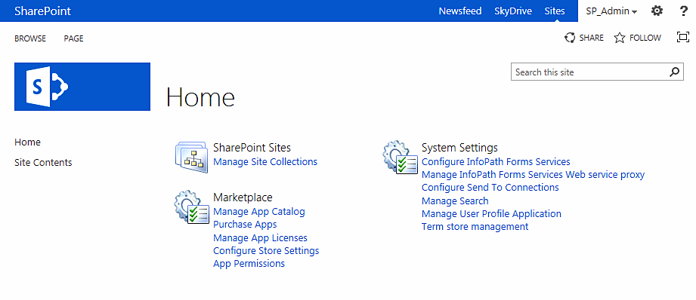

1. From your tenant admin site click **Manage User Profile Application**.  
  
2. On the Manage Profile Service page under People click **Manage User Profiles**.  
  
3. On the Manage User Profiles page type the users name in the “Find Profiles” box and click **Find**.  
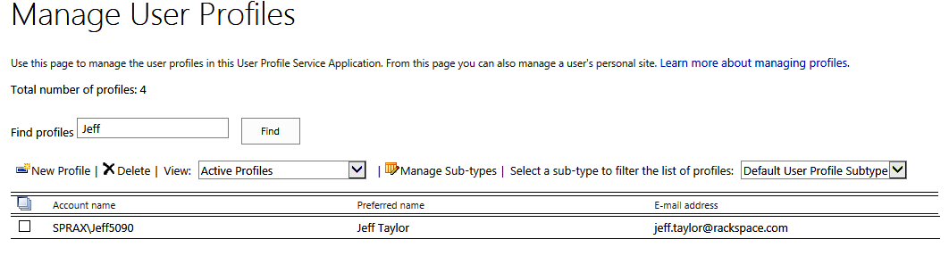

4. Scroll over the users Account name and click the **drop-down arrow**.  
  
5. From the drop-down click **Edit My Profile**.

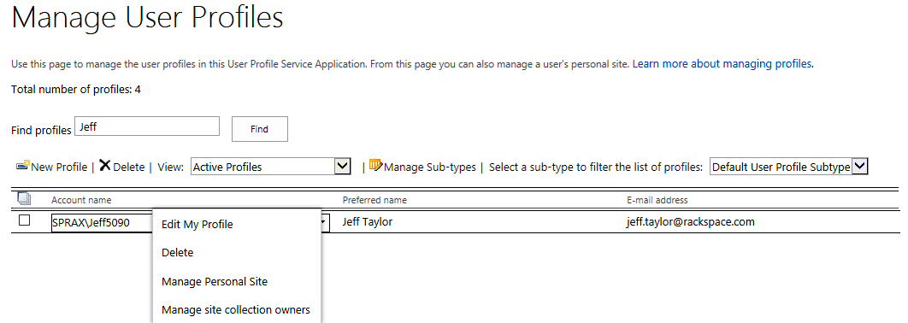

*On the Edit User Profile page it is important to take note of all of the different fields you have the ability to change as a Site Collection Administrator.*

6. Once you have made the changes you wanted BE SURE to click **Save and Close** so your changes are saved.

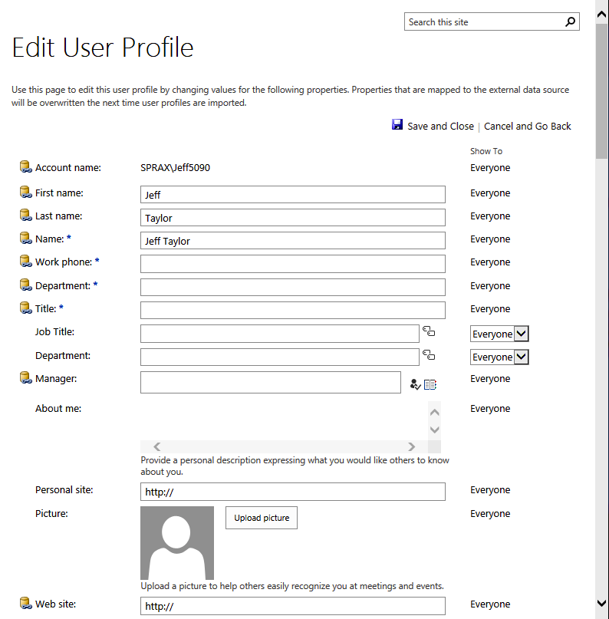

Its as simple as that!